Department of Computer Science and Engineering (Data Science)
CSDS-A | Batch A13 (CSE - Data Science, Section A)
AI-Enabled Digital Examination Seating Management System
(SeatWise)
S.No. | Student name | Roll / hall ticket no.
1 | A.SANJAY | 23K91A6702
2 | CH.NAVEEN | 23K91A6743
3 | D.KOTESH | 24K95A6705
4 | A.AKSHITH | [Roll number to be confirmed]
Under the guidance of: [GUIDE NAME], [DESIGNATION]
METHODOLOGY, NOVELTY AND KEY CONTRIBUTIONS
This document describes how SeatWise works from end to end, why its algorithms were chosen, what is new in it compared with the base paper, and the contributions of the project. All figures are measured values from the project's own artefacts.

1 Overall Methodology
The method turns the seating problem into three smaller, separately checkable problems and wraps them in a pipeline. The first is data preparation: uploaded files are parsed and validated, and the accepted rows become plain data types. The second is allocation (Stage A), which decides which candidates go to which hall and which colour class of the hall's seat grid each paper uses. The third is layout (Stage B), which decides the exact seat of each candidate inside the class that Stage A gave to the candidate's paper. An independent validator then re-checks the whole plan.
The key design decision is to enforce the most important rule, that no two neighbours write the same paper, structurally rather than by search. If seats are coloured so that seats of one colour are never neighbours, and each paper in a hall is confined to a single colour, then two candidates of one paper can never be neighbours, whatever Stage B does. The remaining rules (roll-number gap, accessible seats, one candidate per seat) are constraints of the Stage B model, and the department mix is a soft objective. Randomness enters in both stages through seeded random weights in the objectives, so the returned plan is one random member of the set of valid plans.
The flowchart is the control flow of the engine's solve function. After loading the sitting, the pre-checks reject impossible requests with reasons. Stage A runs in two passes, the first finding the best allocation and the second choosing among equally good allocations with seeded random weights. Candidates are split between halls with a seeded shuffle, and Stage B lays out every hall in parallel. A hall that finds nothing within its time budget is retried with four times the budget; if it still fails, its capacity is eased and Stage A is re-run, at most five times. A successful result is re-checked by the independent validator and stored with the seed, rules and three SHA-256 hashes.
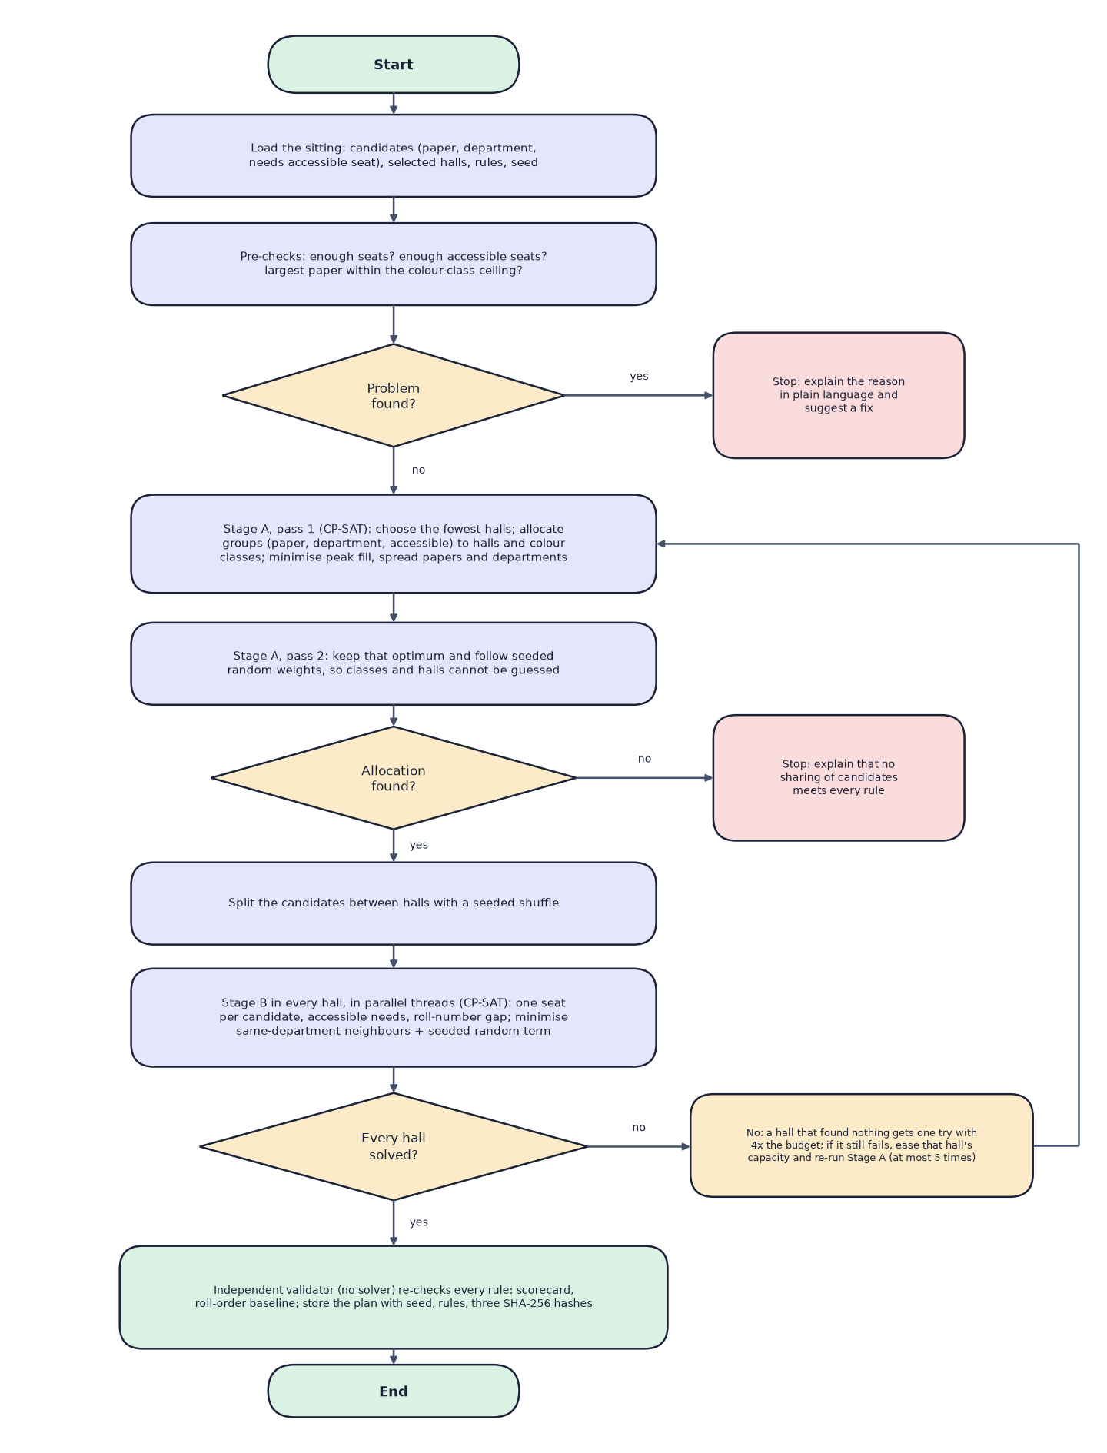
Fig. 1: Flowchart of the core seating algorithm

2 Dataset
SeatWise does not depend on any external dataset. It ships with a seeded, synthetic sample dataset so that the product can be demonstrated and tested end to end, and with empty import templates for real data. The sample was generated by scripts/generate_sample_data.py with seed 2026. No real person, organisation or record is involved: names are random combinations of common first and last names and e-mail addresses use the reserved example.com domain. The data is produced by the project itself and may be used and modified with it. The same seed always reproduces byte-identical files.
Table 1: The sample dataset
Item | Value
Source and licence | Generated by the project (seed 2026); free to use with the product
Departments and courses | 7 departments (ACF, SWE, DAN, MCD, ELS, BMG, HCA); 49 courses, 7 per department
Candidates | 908 candidates; roll numbers such as ACF24017; about 1% (10 candidates) need an accessible seat
Registrations | 2,724 (each candidate sits three courses)
Halls | 14 halls in 3 buildings, 6 x 6 to 10 x 12 seats; 871 usable seats; aisles and blocked seats; 4 halls list accessible seats
Timetable | 6 sittings over 3 days; 397 to 511 candidates and 7 to 9 papers per sitting; SWE-202 and DAN-202 share one question paper
Size on disk | About 145 KB of CSV and Excel files
Train, validation, test split | Not applicable: nothing is trained

The sample is built so that it exercises every rule. Each department has exactly one examination in every sitting, which produces sittings of seven to nine papers. Second-year candidates choose one of two electives, so candidates of one department with neighbouring roll numbers write different papers in the same sitting, which exercises the roll-gap rule. The two courses that share a paper exercise the subject-combination rule.
Table 2: Import file schema
File | Required columns | Optional columns
courses | course_code, course_name, department_code | department_name (needed the first time a department appears)
candidates | roll_no, full_name, department_code, course_codes | needs_accessible_seat, email, date_of_birth
halls | hall_code, hall_name, rows, columns | building, floor, blocked_seats, accessible_seats, aisles_after_columns
timetable | session_date, start_time, end_time, course_code | paper_group

2.1 Benchmark scenarios
The engine benchmark uses eight seeded scenarios generated in memory by ml/scenarios.py, so they are rebuilt identically from their seeds and are not stored as files. Each scenario has roughly 1% of candidates needing an accessible seat and a target hall fill of 80%.
Table 3: Benchmark scenarios
Scenario | Candidates | Papers | Depts | Halls | Seats | Adjacency | Roll gap
xs-150 | 150 | 4 | 3 | 3 | 212 | 8 | 5
s-300 | 300 | 6 | 4 | 6 | 398 | 8 | 5
m-600 | 600 | 8 | 6 | 12 | 752 | 8 | 5
l-1000 | 1,000 | 10 | 7 | 19 | 1,359 | 8 | 5
xl-2000 | 2,000 | 14 | 8 | 39 | 2,522 | 8 | 5
m-600-adj4 | 600 | 8 | 6 | 12 | 752 | 4 | 5
m-600-gap0 | 600 | 8 | 6 | 12 | 752 | 8 | 0
m-600-gap10 | 600 | 8 | 6 | 12 | 752 | 8 | 10

3 Data Preprocessing

3.1 Import parsing and validation
Uploads are read from CSV or XLSX with flexible header names (for example Roll No, roll_number and candidate_id are all accepted for roll_no). Lists are split on ;, , or |, and dates are accepted in two formats. A combined workbook with four sheets, or a single file of one kind, can be uploaded. Every row is then checked, and nothing is saved until the administrator confirms the import; the data is checked again at that moment in case something changed in between.
- required columns present and values well formed (times, dates, integers, yes or no);
- duplicate codes and roll numbers; unknown departments or courses;
- seat labels outside the hall layout, a seat both blocked and accessible, aisle positions outside the grid;
- end time not after start time; a shared-paper group split across sittings;
- a candidate registered for two papers in the same sitting (a timetable clash); a sitting larger than all halls together (a warning).
Errors block the import; warnings do not. For example, a hall that lists no accessible seats receives two front-row seats by default and a warning, which is why the sample import reports 10 warnings and 0 errors for its 1,020 rows.

3.2 Preparation of the engine inputs
For each sitting, the plan service builds the engine's inputs. Candidates become EngineCandidate records with a paper key, which is the paper group when courses share a question paper and the course code otherwise, a department and an accessibility flag. Each hall becomes an EngineHall with its dimensions and the sets of blocked seats, accessible seats and aisle positions. Candidates are then grouped by (paper, department, accessible need), and these groups are the units that Stage A allocates to halls. Roll numbers are split into a prefix and a trailing number (ACF24017 becomes ACF and 24017), and only numbers with the same prefix are compared by the roll-gap rule.

4 Algorithm Choice and Justification
Several families of methods can produce seating plans. The table compares them against the needs of the project.
Table 4: Candidate methods for seat allocation
Method | Hard-rule guarantee | Randomness | Reproducible | Verdict
Sort by roll number | None | None | Yes | Fails the main rule (measured: 1,253 violations at 600 candidates)
Zipper or round-robin interleave | Only for two subjects in a line | None | Yes | Predictable; leaves 281 violations at 600 candidates
Random shuffle | None | Full | With a seed | Leaves 265 violations at 600 candidates
Greedy graph colouring | Same-course neighbours, heuristically | Limited | Yes | No proof of success; hard to add other rules
Genetic or annealing search | None (soft penalties) | Full | With a seed | May end with violations; slow to converge
CP-SAT (constraint programming) | Exact, or a proof of infeasibility | Seeded objective | Deterministic budget | Chosen

CP-SAT was chosen for four reasons. It returns either a plan that satisfies every hard constraint or a proof that none exists, which lets the system explain impossible requests honestly. Adding a rule means adding a constraint, not redesigning a heuristic. Its objective supports lexicographic goals (first spread papers and departments, then follow random weights). And a deterministic time limit, together with a fixed number of workers per hall and a fixed order of candidates, makes a run reproducible from its seed, which was one of the project's objectives.
A single monolithic model over all seats of all halls would be large and slow. Splitting the problem into an allocation stage and a per-hall layout stage keeps each model small, lets the halls be solved in parallel, and is what makes the colour-class construction possible.

5 Mathematical Formulation
Notation. Let C be the candidates of a sitting and H the selected halls. Candidate c has a paper p(c), a department d(c), a roll number r(c) with prefix and number, and a flag a(c) that is true when an accessible seat is needed. Hall h is a grid of rows and columns whose usable seats form the set S(h); A(h) is the set of accessible seats.

5.1 Seat graph and colour classes
Two usable seats of a hall are neighbours if they are adjacent in a row, a column or, in 8-neighbour mode, a diagonal, and no aisle lies between them. Blocked seats and aisles only remove edges. The seat at row i and column j receives the colour class
Listing: colour classes of the seat grid
kappa(i, j) = 2 * (i mod 2) + (j mod 2) (8 neighbours: 4 classes)
kappa(i, j) = (i + j) mod 2 (4 neighbours: 2 classes)

Lemma. Two different seats of the same class are never neighbours. Proof. In 8-neighbour mode, two seats of one class have the same row parity and the same column parity, so their row difference and their column difference are both even; since the seats differ, at least one difference is 2 or more, and neighbours differ by at most 1 in each direction. In 4-neighbour mode, seats of one class have the same parity of i + j, whereas neighbours differ by exactly 1 in i + j. Removing edges (aisles, blocked seats) cannot create adjacency. The class sizes are therefore the largest sets of seats that can safely hold one paper, and the per-paper ceiling of a hall is its largest class.

5.2 Stage A: allocation
Group candidates by g = (paper, department, accessible need) and let N(g) be the size of group g. The variables are integers n(h, g) with 0 <= n(h, g) <= min(N(g), capacity(h)), booleans z(h, p, k) meaning that paper p uses class k in hall h, and integers m(h, p, k) for the number of candidates of paper p seated in class k of hall h. The constraints are:
Listing: Stage A constraints
sum_h n(h,g) = N(g) -- every group is fully placed
sum_g n(h,g) <= capacity(h) -- no hall is over capacity
sum_k z(h,p,k) <= 1 -- one class per paper per hall
m(h,p,k) <= |S(h,k)| * z(h,p,k) -- class size bounds the share
sum_k m(h,p,k) = sum_{g in p} n(h,g) -- shares add up to the paper
sum_p m(h,p,k) <= |S(h,k)| -- classes are not over-filled
accessible candidates in class k <= |A(h) in k|
100 * occupancy(h) <= capacity(h) * peak -- peak fill bound

The first pass minimises a lexicographic objective, with the peak fill weighted most heavily, followed by the largest paper share and the largest department share of each hall, and a penalty on each (hall, department, class) triple that a department spans in several classes. The second pass keeps the optimum (primary <= best) and maximises a weighted sum of the z variables with seeded random integer weights in the range 0 to 999, so which class and hall each paper receives cannot be predicted. The compact strategy first selects the fewest, largest halls into which a greedy best-fit packing can place every paper.

5.3 Stage B: seat layout of one hall
After a seeded shuffle gives each hall its candidates, the layout of hall h is a boolean model. Let K(c) be the seats of the class that Stage A assigned to p(c), intersected with A(h) if a(c) is true. The variable x(c, s) is 1 when candidate c sits on seat s in K(c):
Listing: Stage B model
sum_s x(c,s) = 1 -- one seat per candidate
sum_c x(c,s) <= 1 -- one candidate per seat
for each pair (i,j): same roll prefix, |r(i)-r(j)| < gap,
different classes, and every seat s of i:
x(i,s) + sum_{t in N(s)} x(j,t) <= 1 -- roll-gap clause
minimise W * sum(penalties) - sum w(c,s) * x(c,s)
penalty = 1 when two neighbours share a department
w(c,s) = random integer in [0,20), W = |C(h)| * 20 + 1

Pairs of candidates in the same class need no roll-gap constraint, because their seats are never neighbours. The weight W makes department mixing take precedence over the random term, which then chooses among equally good layouts. The model is seeded with a random hint and solved with one deterministic worker and a deterministic time budget, so the result depends only on the seed and inputs.

5.4 Why every hard rule holds
1. No seat has two candidates and every candidate has one seat (Stage B constraints).
2. Same-paper neighbours are impossible: all candidates of one paper in a hall sit in one class (Stage A), and seats of one class are never neighbours (Lemma). A shared question paper is one paper key, so it is covered.
3. Roll-number gaps hold for candidates in different classes by the Stage B clauses, and for the same class by the Lemma.
4. Accessible needs hold because K(c) contains only accessible seats for such candidates.
5. Independently of this argument, the validator re-checks all four rules on the finished plan, and a plan that fails is never stored.
Reproducibility follows from deterministic components: sub-seeds are derived from the plan seed with SHA-256, candidates are processed in a fixed order, and each solver call uses one worker with a deterministic time limit. The plan stores a fingerprint of the inputs, a hash of the solver result and a hash of the current seating.

6 Model Architecture, Configuration and Tuning
The seating engine is a constraint model, not a neural network, and it has no trained parameters. There is therefore no training set, validation set, test set, loss curve or epoch count. What can be configured and tuned is the solver, and the benchmark tunes the one setting that affects speed, the per-hall time budget.
Table 5: Engine configuration
Setting | Value | Where
Solver | OR-Tools CP-SAT 9.15.6755 | requirements.txt
Per-hall deterministic budget (Stage B) | 0.15, tuned | models/engine_profile.json; override SOLVER_HALL_BUDGET
Stage A budget | 0.3 (pass 2: half; a stretch to 4x if no allocation is found) | engine.py
Workers per hall | 1 (deterministic) | engine.py
Halls solved in parallel | all CPU threads | SOLVER_THREADS
Random weight range | 0-19 per candidate-seat (Stage B); 0-999 per class variable (Stage A) | stage_b.py, stage_a.py
Re-balancing retries | 5 | SOLVER_MAX_RETRIES
Hall retry factor | 4x budget once, then ease and re-balance | engine.py

The budget trades department mix, a soft preference, against speed. The benchmark tried five budgets on the 600- and 1,000-candidate scenarios with two seeds each and chose the fastest budget whose department mix is within 10% of the best seen. Every budget met every hard rule. The smallest budget is slower overall because some halls run out of time and are solved again with a larger budget.
Table 6: Tuning the per-hall budget
Per-hall budget | Same-department pairs (mean) | Session solve (s) | Hard rules
0.1 | 127.2 | 3.72 | all met
0.15 (chosen) | 123.2 | 2.63 | all met
0.25 | 119.2 | 3.56 | all met
0.4 | 116.0 | 5.01 | all met
0.6 | 114.0 | 6.58 | all met

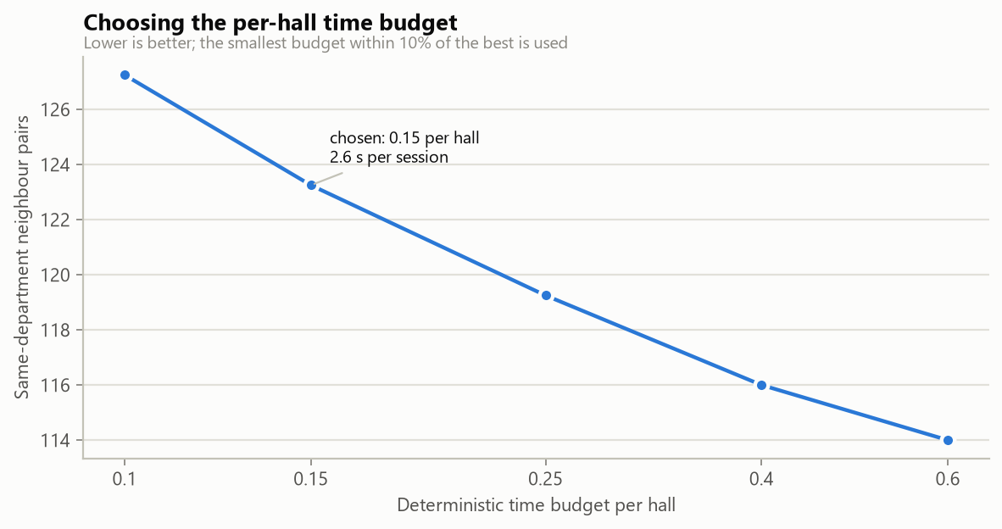
Fig. 2: Budget tuning: session solve time against department mix

7 Base Paper Analysis
The base paper is P. Yukth, I. S. Mahmood, K. H. Shashank, S. G. Thejus and M. S. Darshini, "Exam Seating Arrangement System," International Journal of Research Publication and Reviews (IJRPR), vol. 6, no. 12, pp. 2093-2105, Dec. 2025. It was written by students and a guide at ATME College of Engineering, Mysuru, and describes a web application called ExamSeater.

7.1 What the base paper does
- Architecture. A Flask application with Jinja2 templates in a Model-View-Controller arrangement, SQLite through SQLAlchemy, pandas for reading uploaded lists, PyPDF2 for PDF text, and ReportLab for output.
- Algorithm. The zipper method: two subject lists are sorted (alphabetically, or by branch when a branch constraint is on) and interleaved with itertools.zip_longest, so that seat 1 holds a student of subject A, seat 2 a student of subject B, and so on. Seats marked blocked are skipped.
- Features. Login for administrators and staff with PBKDF2-hashed passwords; management of rooms, exams and staff; a visual grid of the room; a PDF seating chart; a history of earlier arrangements; and a public page where students search for a seat by USN or name.
- Evidence. Screenshots of the working application. The paper states one performance requirement, that a batch of 100 students should be processed in under 3 seconds, but it reports no measurement, no dataset and no comparison.
- Future work named by the authors. A mobile application, e-mail and SMS notification, facial-recognition attendance, cloud deployment and a drag-and-drop seat map.

7.2 Strengths
- A complete, understandable system that a college can run on a single PC with free software.
- A public lookup page, which removes crowding at notice boards.
- Blocked seats and multiple exam types are supported, and the output is printable.

7.3 Limitations
- Interleaving covers two subjects at a time. With three or more papers in a sitting, or with diagonal neighbours, the pattern does not by itself prevent same-paper neighbours.
- The seating pattern is fixed and therefore predictable; no randomness is used.
- There are no roll-number spacing rules, no accessible-seat handling and no department balancing beyond a sort order.
- No measured results are reported, so the claims cannot be compared quantitatively.
- No attendance, no audit trail, no reproducibility mechanism and no live validation of manual changes.

7.4 What SeatWise adopts and what it changes
Table 7: Base paper compared with SeatWise
Aspect | Base paper [1] | SeatWise
Data input | CSV or PDF student list, manual entry | Excel or CSV templates for four data kinds, validated row by row
Allocation | Zipper interleave of two subjects | Two-stage CP-SAT optimisation for any number of papers
Neighbour rule | Alternate subjects in a line | No same-paper neighbour in 8 or 4 directions, aisles respected
Other rules | Optional branch rule, blocked seats | Roll gap, accessible seats, department mix, capacity, shared papers
Randomness | None (fixed pattern) | Seeded random choice among valid plans
Reproducibility | Not addressed | Seed, three SHA-256 hashes, Verify, audit trail
Manual edits | Re-run the generator | Drag-and-drop with live rule check and reasons
Outputs | On-screen grid, PDF chart | Charts, invigilator sheets, hall lists, QR slips, attendance report
Seat lookup | Public search by USN or name | Public lookup by candidate ID with hall map and QR slip
Attendance | Future work | Tablet register with scan, lock and report
Evaluation | Screenshots; 3 s target | Benchmark: 8 scenarios, 3 baselines, 24 of 24 plans valid
Back end | Flask, SQLite | FastAPI, SQLite, React front end

8 Novelty and Key Contributions
The base paper [1] allocates seats with a zipper algorithm that interleaves two subject lists. SeatWise keeps the idea of a data-driven, rule-based allocation but changes how the rules are enforced. The points below are new relative to the base paper and the systems reviewed in Chapter 2; we do not claim that they are new to the field as a whole, since constraint programming and graph colouring are established techniques [11]-[14].
1. Rules guaranteed by construction. A hall's seats are coloured so that seats of one colour class are never neighbours. Stage A confines each paper to one colour class per hall, which makes same-paper neighbours impossible before any seat is chosen. This works for any number of papers and for diagonals, where a two-subject zipper does not.
2. Two-stage constraint optimisation. Stage A (hall and colour-class allocation) and Stage B (seat layout per hall) are both modelled and solved with OR-Tools CP-SAT [14], with halls laid out in parallel and a bounded retry strategy.
3. Controlled randomness. Among all valid plans the engine returns one chosen by a seeded random objective. Measured unpredictability matches a pure random shuffle (roll-to-seat correlation 0.065; 1.0% repeated neighbour pairs), while every hard rule still holds.
4. Reproducibility and audit. Every plan stores its seed, rules, engine version and three SHA-256 fingerprints. The Verify action re-runs the engine and proves that the plan was not hand-picked. Every move, publication and download is logged.
5. An independent validator. A plain-Python checker, which shares no code with the solver model, scores every plan and backs the live swap checks, so the seat map, the exports and the benchmark agree.
6. Live, explained editing. The seat map shows every possible target seat as green or red and gives the reason for each red seat, so manual changes cannot break a rule unnoticed.
7. A complete workflow. Validated import, QR seat slips, a public lookup page, tablet attendance with a lock, analytics and team management are built around the engine, so one stored plan serves the whole examination day.
8. A measured, honest evaluation. A seeded benchmark of 8 scenarios and three manual baselines gives 24 of 24 plans meeting every hard rule, 2.4 s for 600 candidates and 4.8 s for 2,000, and reports its own limits, such as a front-row bias of 4.7 percentage points.

